IBM – Anti-Money Laundering Dashboard

Submitted by:
Name: S.SHERENE
Roll no: E25FA067
Department: B.Com FinTech and AI
Year of Study: 2nd Year
Introduction
For this project, I used Dataset 5(IBM – Anti-Money Laundering) in Power BI to analyse anti-money laundering (AML) transactions and fraud-related activity. The dashboard brings together summary cards and charts that show transaction volume, transaction value, fraud status, activity over time, and alerts by type. My aim was to turn the transaction data into a visual report that is easier to explore than a plain table and that helps users notice patterns which may need closer attention.
Objectives
Before working with the dashboard, I focused on a few main objectives:
- Summarise the overall number and value of transactions.
- Compare transactions across fraud-status categories.
- Track transaction activity over time using the timestamp field.
- Examine how fraudulent transaction activity changes over time.
- Compare transaction value across fraud-status categories.
- Analyse alerts by type and make the dashboard interactive with slicers.
Dataset Description
Dataset 5 is used in the supplied Power BI report for transaction and fraud analysis. The fields and measures visible in the report include:
- TIMESTAMP - the time field used to display transaction activity over time.
- IS_FRAUD - the field used to separate transactions by fraud status.
- Total Transactions - a measure used to summarise transaction count.
- Fraudulent Transactions - a measure used to summarise transactions classified as fraudulent.
- Total Transaction Amount - a measure used to summarise transaction value.
- Total Accounts - a measure used to summarise the accounts represented in the data.
- Alert ID and Alert Type - fields used in the alert analysis.
These fields allow the dashboard to show both the scale of transaction activity and how it is distributed across fraud-status and alert categories.
Data Preparation
Before interpreting the visuals, the main data checks for this type of dashboard are to make sure that the fields are correctly formatted and that the totals are reliable. The key preparation steps are:
- Used the given Dataset 5 Power BI file and review its existing data model.
- Confirmed that TIMESTAMP is recognised as a date/time field so the time-series charts are sorted correctly.
- Checked that transaction amount is stored as a numeric field and is aggregated consistently.
- Reviewed the IS_FRAUD categories so the fraud-status chart is interpreted correctly.
- Checked for missing timestamps, blank transaction amounts, and duplicate identifiers where applicable.
- Verified the existing measures and their filter behaviour before recording final KPI values.
Measures and KPIs
The dashboard includes four main KPI cards:
- Total Transactions — summarises the number of transactions in the current selection.
- Fraudulent Transactions — summarises the transactions classified as fraudulent.
- Total Transaction Amount — shows the transaction value represented by the current selection.
- Total Accounts — summarises the accounts represented in the data.
These measures give a quick overview of the data before the user moves to the detailed charts. Their displayed values change according to the active filters.
Dashboard Components
The finished dashboard contains the following visuals:
KPI Cards
The KPI cards are placed prominently to give an at-a-glance summary of Total Transactions, Fraudulent Transactions, Total Transaction Amount, and Total Accounts. They help users understand the size of the dataset and the scale of activity before looking at individual categories or time periods.
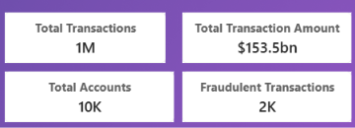
Transaction Distribution by Fraud Status
A donut chart compares the distribution of transactions across the values of IS_FRAUD. This makes it easier to see how transaction counts are split between the available fraud-status categories. The chart is most useful when considered alongside the overall transaction count and other indicators.
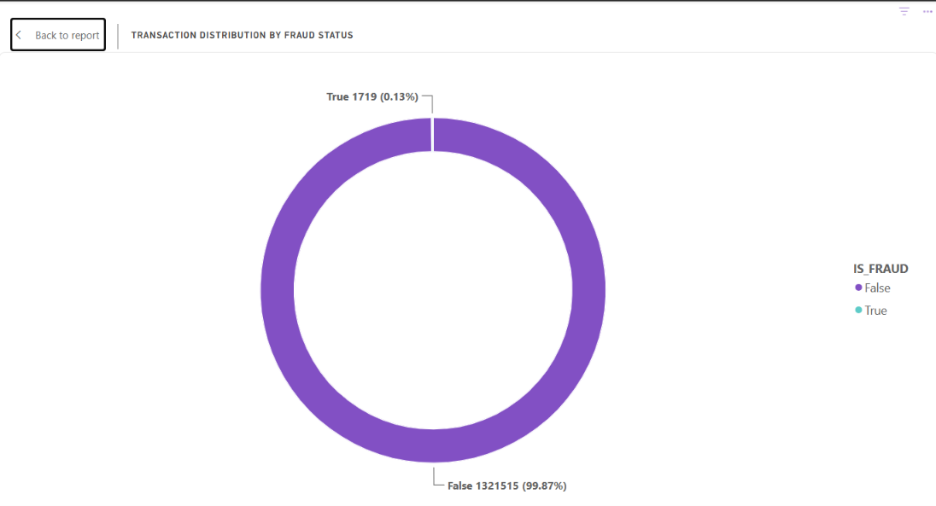
Transaction Volume Across Timestamp
A line chart displays transaction volume across the timestamp field. It helps the user follow changes in activity over time and notice peaks, drops, or periods that may deserve a closer look.
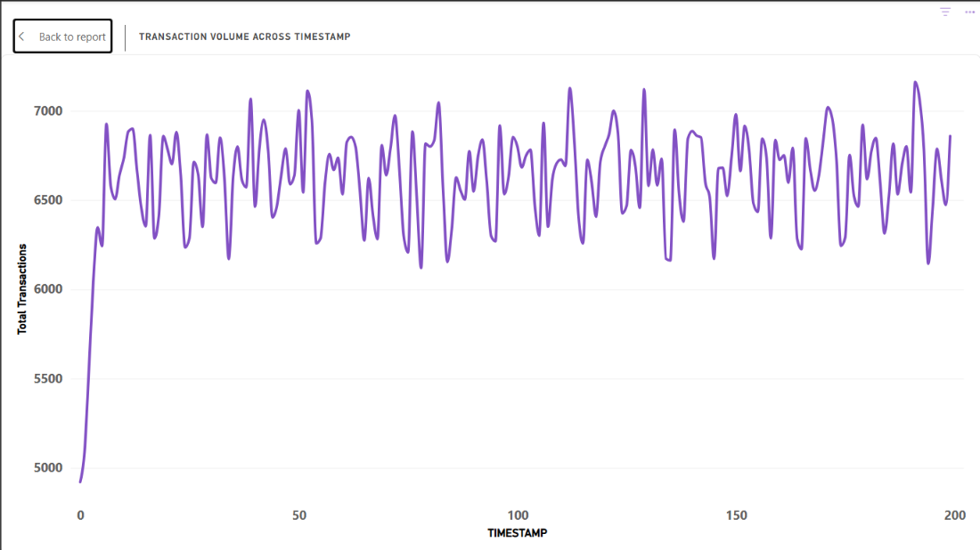
Fraudulent Transaction Volume Across Timestamp
A separate time-series visual focuses on transaction activity associated with fraud status over time. It helps users explore when fraudulent transactions occur and identify any visible spikes or clusters for further review.
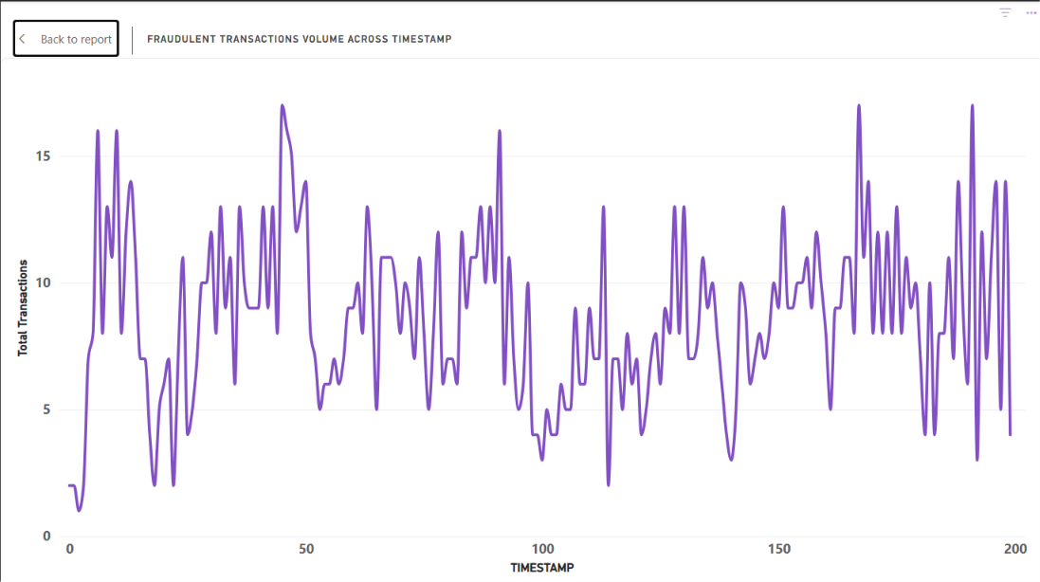
Total Transaction Value by Fraud Status
A clustered column chart compares total transaction value across fraud-status categories. This adds a monetary perspective to the count-based visuals: a category with fewer transactions may still represent a substantial transaction value.
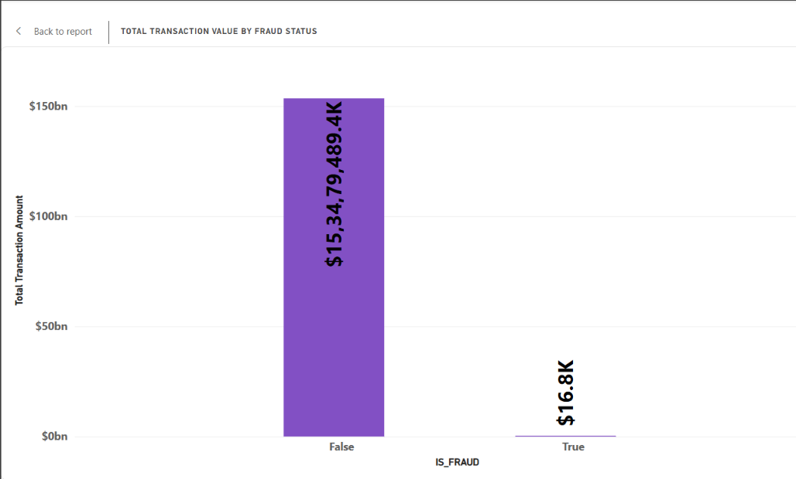

Alerts by Alert Type
A clustered bar chart compares alerts across alert types. It helps users identify which alert categories occur more frequently and where review effort may need to be focused. A higher alert count is a signal for review, not proof of money laundering by itself.
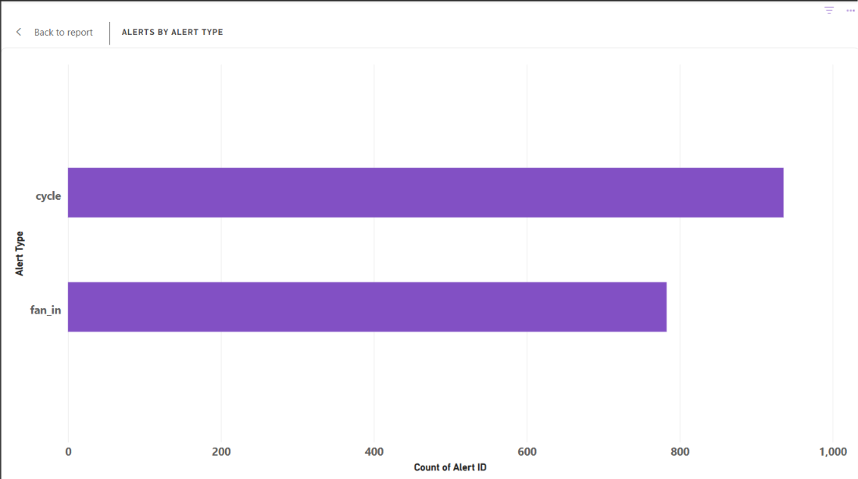
Slicers Used
The Interactive AML Dashboard includes slicers for Fraud Status and Alert Type. These filters allow users to focus on selected categories and see how the relevant KPI cards and charts respond. This makes it possible to explore the dashboard from different angles rather than relying on one fixed view.
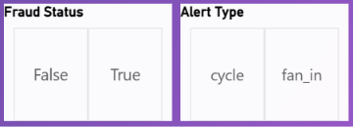
AML Tooltip
A tooltip is a small pop-up box that displays additional information when a user moves the mouse pointer over or clicks on an element, such as a button, chart, or data point. It helps users understand the data without displaying too much information on the screen. In Power BI, tooltips provide extra details about visualisations, such as sales, profit, or expenses, when hovering over them. They make reports more interactive and easier to understand.
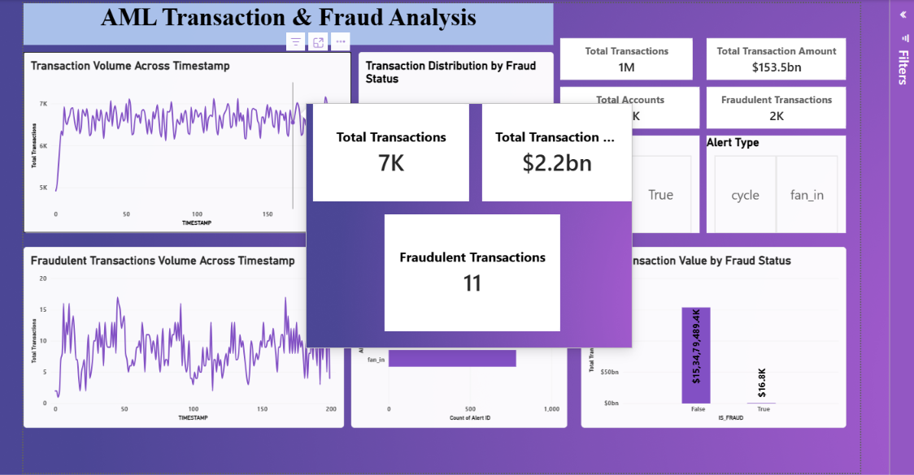
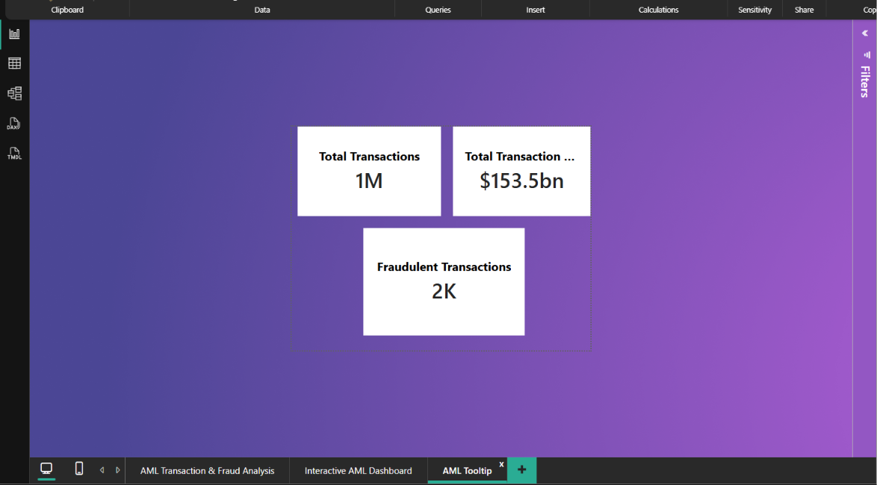
Key Findings
The dashboard brings together several useful views of AML-related transaction activity. The main observations that can be explored from the visuals are:
- The KPI cards provide a quick summary of transaction count, fraudulent transaction count, transaction value, and accounts represented.
- The fraud-status donut chart shows how transaction counts are distributed across the available categories. There is false by 99.87% and true by 0.13%
- The time-series charts can be used to spot changes in transaction activity and periods of increased fraudulent activity.
- Comparing transaction value by fraud status provides context beyond transaction counts alone.
- The alert-type chart helps highlight categories with more alerts and supports prioritising further review.
- The Fraud Status and Alert Type slicers make it easier to investigate selected parts of the data.
Conclusion
Working on this project shows how Power BI can bring transaction, fraud-status, and alert information together in one interactive dashboard. The KPI cards provide a quick summary, while the donut chart, line charts, column chart, and bar chart make it easier to examine transaction distribution, activity over time, transaction value, and alert categories. The slicers allow users to explore selected categories and compare the resulting views. Overall, the dashboard can support monitoring and help prioritise transactions or alerts for review, while any suspected fraudulent activity still needs proper investigation and context.
References
- Microsoft Power BI Desktop.
- Dataset 5- IBM- Anti-Money Laundering
- Microsoft Power BI documentation.

